David Forrester, author of Fordington Remembered: Growing up in and around Dorchester and Mill Street Dorchester: Thomas Hardy’s Mixen Lane.

These books describe the lives of ordinary people living in the poorest area of Dorchester and provide a fascinating picture of a bygone era.

David has also made two YouTube videos which you can watch by clicking on this link.

Mill Street https://www.youtube.com/watch?v=yfy3jUN5gvI&t=9s
Mill Street Dorchester - YouTube
A video presented by Local Historian and Author David J. Forrester about Mill Street in Dorchester, the inspiration for Thomas Hardy's Mixen Lane. David also wrote a book on the subject which is ...
www.youtube.com
Ivy Gale https://www.youtube.com/watch?v=RMsyqhOP1V0
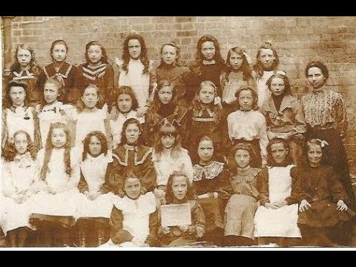 | The Memories of Ivy Gale  Dorset local historian and Author David J Forrester recounting his interview with local nonagenarian Ivy Gale about her life and times in and around Dorchest...  www.youtube.com

